**Roll No:63**

**Student Name:Rutuja Ashok Sathe**

**Assignment No: 3**

**Design at least 10 SQL queries for suitable database application using SQL DML statements: all types of**

**Join, Sub-Query and View**.

Program and Output:

Create table Branchmaster(branch_id int, branch_name varchar(15));

Insert into branchmaster values (1, ’Kharadi’);

Insert into branchmaster values (2, ’wagholi’);

Insert into branchmaster values (3, ’Hadapsar’);

mysql> use rutujadb

Database changed

mysql> create table Branchmaster(branch_id int,branch_name varchar(15));

Query OK, 0 rows affected (0.10 sec)

mysql> insert into Branchmaster values(1,'Kharadi');

Query OK, 1 row affected (0.02 sec)

mysql> insert into Branchmaster values(2,'wagholi');

Query OK, 1 row affected (0.01 sec)

mysql> insert into Branchmaster values(3,'Hadapsar');

Query OK, 1 row affected (0.01 sec)

mysql> select * from branchmaster;

+-----------+-------------+

| branch_id | branch_name |

+-----------+-------------+

| 1 | Kharadi |

| 2 | wagholi |

| 3 | Hadapsar |

+-----------+-------------+

3 rows in set (0.00 sec)

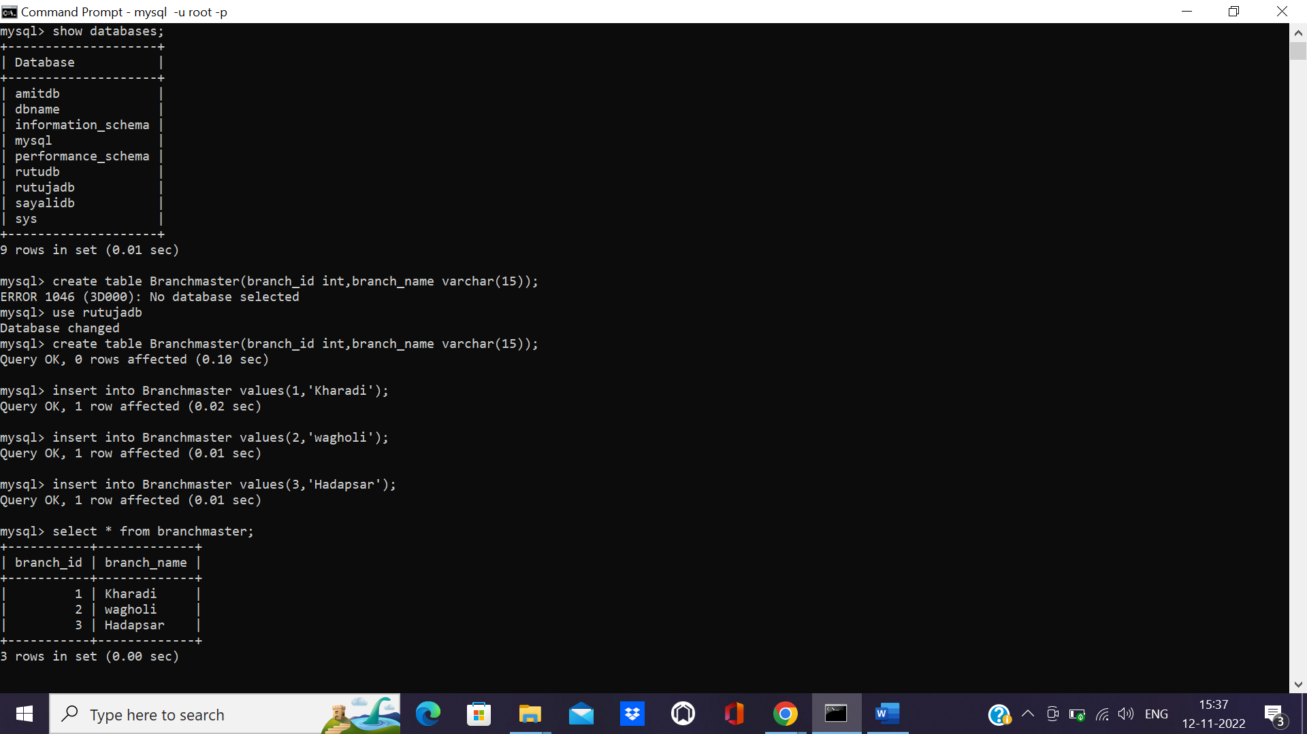

Create table Empmaster(emp_id int,emp_name varchar(15), branch_id int,

salary int, dept varchar(15),manager_id varchar(10));

mysql> create table Empmaster(emp_id int,emp_name varchar(15),branch_id int,salary int,dept varchar(15),manager_id varchar(10));

Query OK, 0 rows affected (0.03 sec)

mysql> select * from Empmaster;

Empty set (0.00 sec)

mysql> insert into empmaster values(10,'rutuja',2,40000,'manager',11);

Query OK, 1 row affected (0.01 sec)

mysql> insert into empmaster values(11,'nita',4,20000,'admin',12);11);

Query OK, 1 row affected (0.01 sec)

mysql> insert into empmaster values(11,'nita',4,20000,'admin',12);

Query OK, 1 row affected (0.01 sec)

mysql> insert into empmaster values(12,'sonali',3,50000,'HR',13);

Query OK, 1 row affected (0.01 sec)

mysql> insert into empmaster values(14,'kajal',1,120000,'senior',14);

Query OK, 1 row affected (0.01 sec)

mysql> insert into empmaster values(15,'priyanka',5,60000,'Assistant',15);

Query OK, 1 row affected (0.01 sec)

mysql> select * from Empmaster;

+--------+----------+-----------+--------+-----------+------------+

| emp_id | emp_name | branch_id | salary | dept | manager_id |

+--------+----------+-----------+--------+-----------+------------+

| 10 | rutuja | 2 | 40000 | manager | 11 |

| 11 | nita | 4 | 20000 | admin | 12 |

| 11 | nita | 4 | 20000 | admin | 12 |

| 12 | sonali | 3 | 50000 | HR | 13 |

| 14 | kajal | 1 | 120000 | senior | 14 |

| 15 | priyanka | 5 | 60000 | Assistant | 15 |

+--------+----------+-----------+--------+-----------+------------+

6 rows in set (0.00 sec)



mysql> create table contactdetails(emp_id int,email_id varchar(20),phone_no int);

Query OK, 0 rows affected (0.02 sec)

mysql> insert into contactdetails values (10,'rutuja@gmail.com',1234567898);

Query OK, 1 row affected (0.01 sec)

mysql> insert into contactdetails values (11,'nita@gmail.com',1234667898);

Query OK, 1 row affected (0.01 sec)

mysql> insert into contactdetails values (12,'sonali@gmail.com',1224667898);

Query OK, 1 row affected (0.01 sec)

mysql> insert into contactdetails values (13,'kajal@gmail.com',1223667898);

Query OK, 1 row affected (0.01 sec)

mysql> insert into contactdetails values (14,'priyanka@gmail.com',1223667998);

Query OK, 1 row affected (0.01 sec)

mysql> select * from contactdetails;

+--------+--------------------+------------+

| emp_id | email_id | phone_no |

+--------+--------------------+------------+

| 10 | rutuja@gmail.com | 1234567898 |

| 11 | nita@gmail.com | 1234667898 |

| 12 | sonali@gmail.com | 1224667898 |

| 13 | kajal@gmail.com | 1223667898 |

| 14 | priyanka@gmail.com | 1223667998 |

+--------+--------------------+------------+

5 rows in set (0.00 sec)

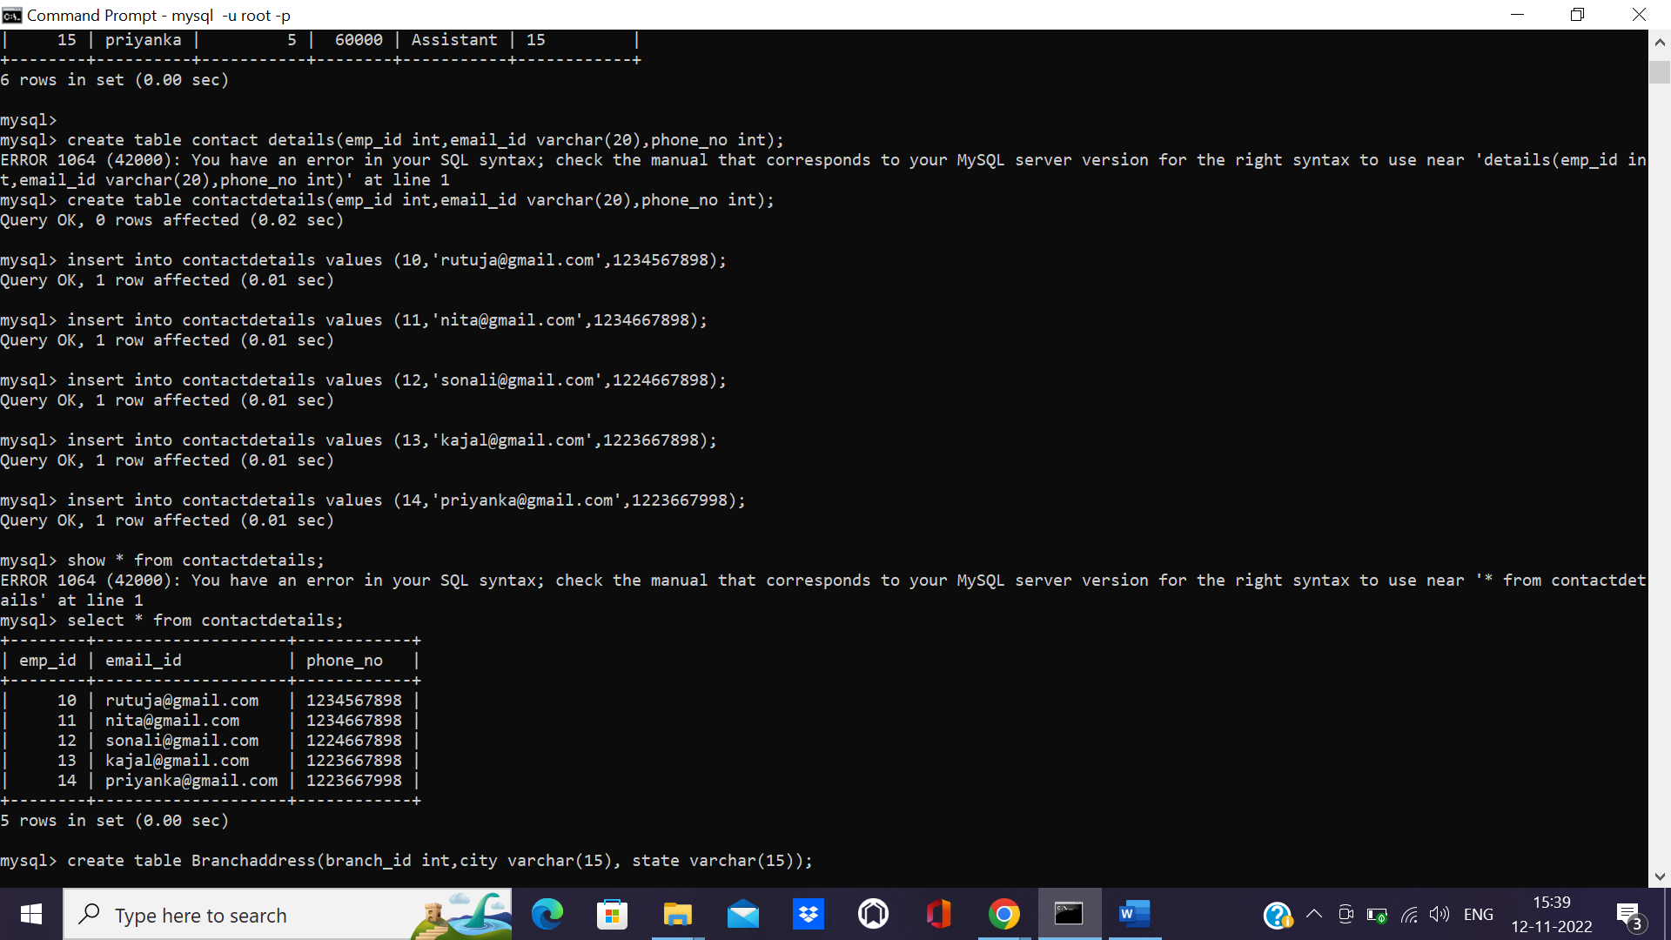

mysql> create table Branchaddress(branch_id int,city varchar(15), state varchar(15));

Query OK, 0 rows affected (0.02 sec)

mysql> insert into Branchaddress values (1,'pune','Maharashtra');

Query OK, 1 row affected (0.01 sec)

mysql> insert into Branchaddress values (2,'Kolkata','West Bengal');

Query OK, 1 row affected (0.01 sec)

mysql> insert into Branchaddress values (3,'Mumbai','Maharashtra');

Query OK, 1 row affected (0.01 sec)

mysql> insert into Branchaddress values (4,'Bangalore','Karnataka');

Query OK, 1 row affected (0.01 sec)

mysql> insert into Branchaddress values (5,'Cuttack','Orissa');

Query OK, 1 row affected (0.01 sec)

mysql> select * from Branchaddress;

+-----------+-----------+-------------+

| branch_id | city | state |

+-----------+-----------+-------------+

| 1 | pune | Maharashtra |

| 2 | Kolkata | West Bengal |

| 3 | Mumbai | Maharashtra |

| 4 | Bangalore | Karnataka |

| 5 | Cuttack | Orissa |

+-----------+-----------+-------------+

5 rows in set (0.00 sec)

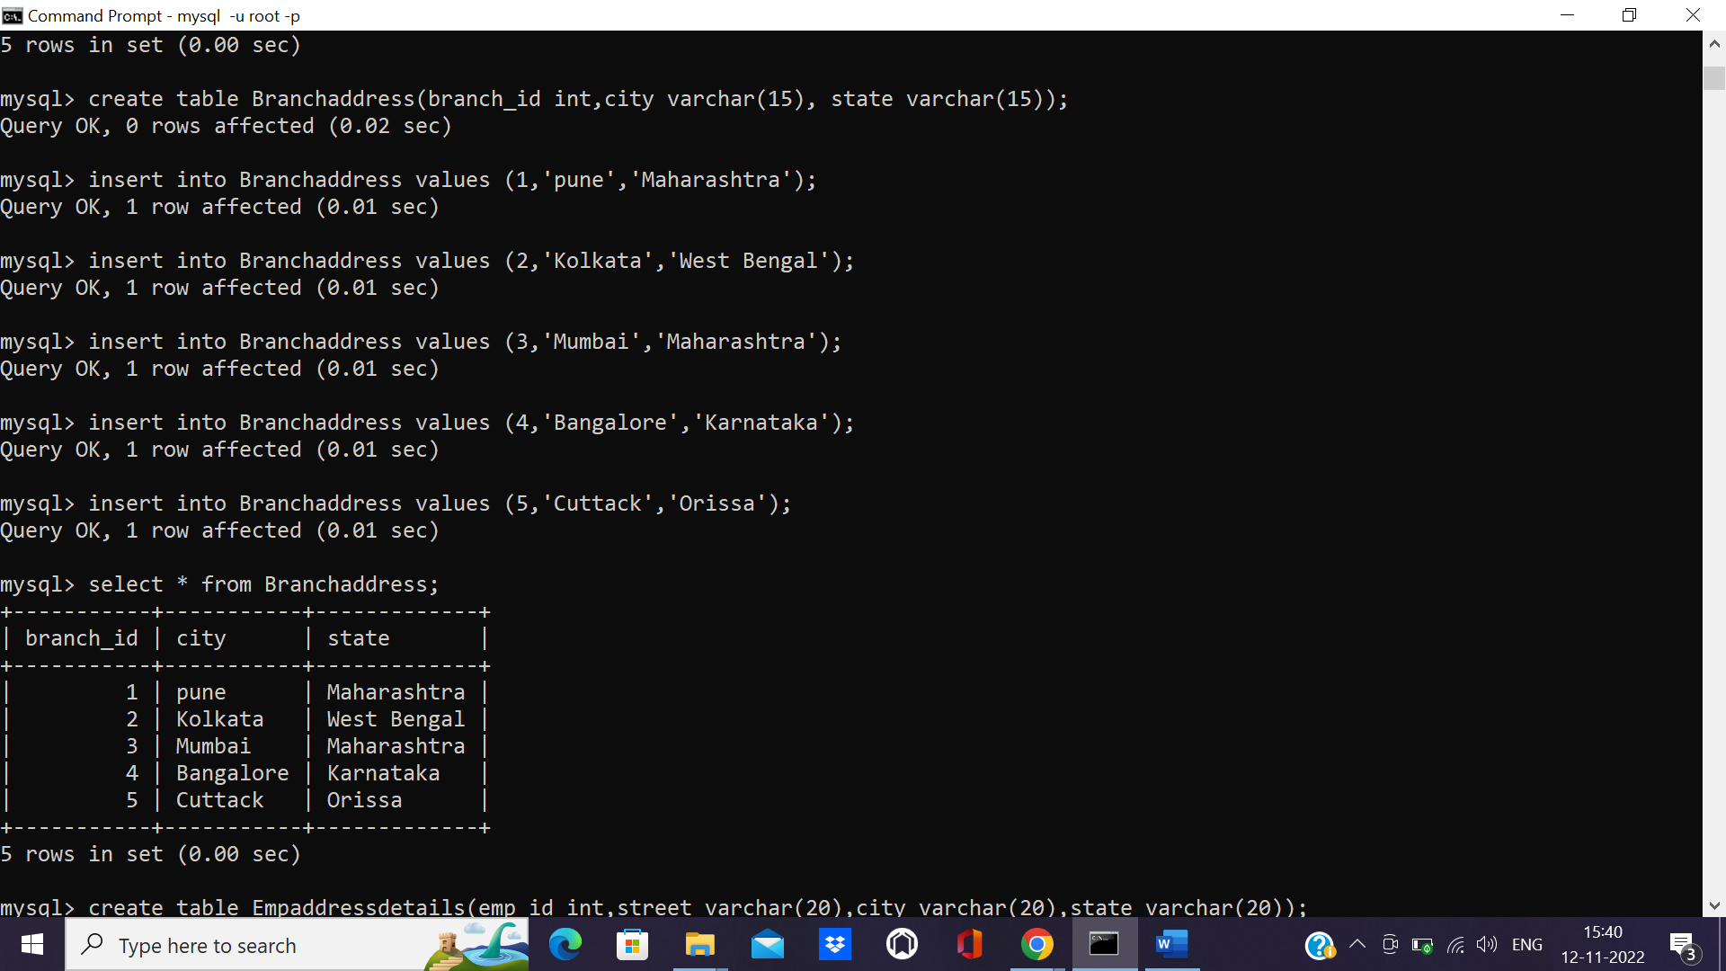

mysql> create table Empaddressdetails(emp_id int,street varchar(20),city varchar(20),state varchar(20));

Query OK, 0 rows affected (0.02 sec)

mysql> insert into Empaddressdetails values (10,'Kharadi','pune','maharashtra');

Query OK, 1 row affected (0.01 sec)

mysql> insert into Empaddressdetails values (11,'Link Road','Mumbai','maharashtra');

Query OK, 1 row affected (0.01 sec)

mysql> insert into Empaddressdetails values (12,'Park stree','Kolkata','West Bengal');

Query OK, 1 row affected (0.01 sec)

mysql> insert into Empaddressdetails values (13,'Roha','Bangalore','Karnataka');

Query OK, 1 row affected (0.01 sec)

mysql> insert into Empaddressdetails values (14,'Street roa','cuttack','Orissa');

Query OK, 1 row affected (0.01 sec)

mysql> select * from Empaddressdetails;

+--------+------------+-----------+-------------+

| emp_id | street | city | state |

+--------+------------+-----------+-------------+

| 10 | Kharadi | pune | maharashtra |

| 11 | Link Road | Mumbai | maharashtra |

| 12 | Park stree | Kolkata | West Bengal |

| 13 | Roha | Bangalore | Karnataka |

| 14 | Street roa | cuttack | Orissa |

+--------+------------+-----------+-------------+

5 rows in set (0.00 sec)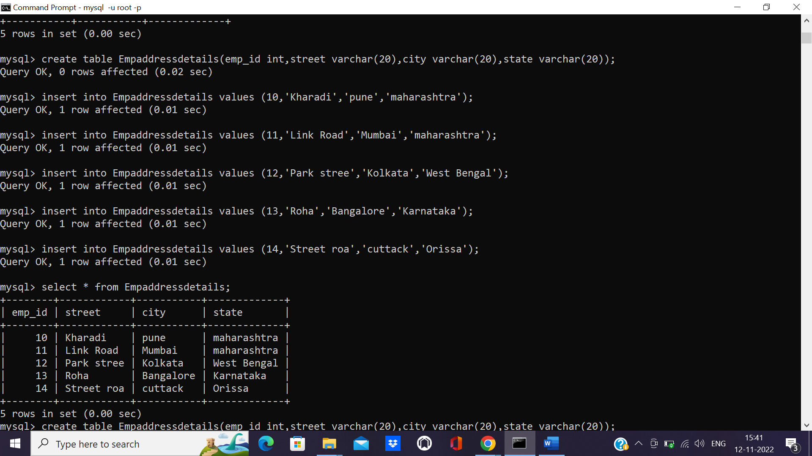

**List the employee details along with branch name using the inner join and in the order of emp_no.**

mysql> select emp_id,emp_name,branch_name from Empmaster e inner join branchmaster b on e.branch_id=b.branch_id order by emp_id;

+--------+----------+-------------+

| emp_id | emp_name | branch_name |

+--------+----------+-------------+

| 10 | rutuja | wagholi |

| 12 | sonali | Hadapsar |

| 14 | kajal | Kharadi |

+--------+----------+-------------+

3 rows in set (0.00 sec)

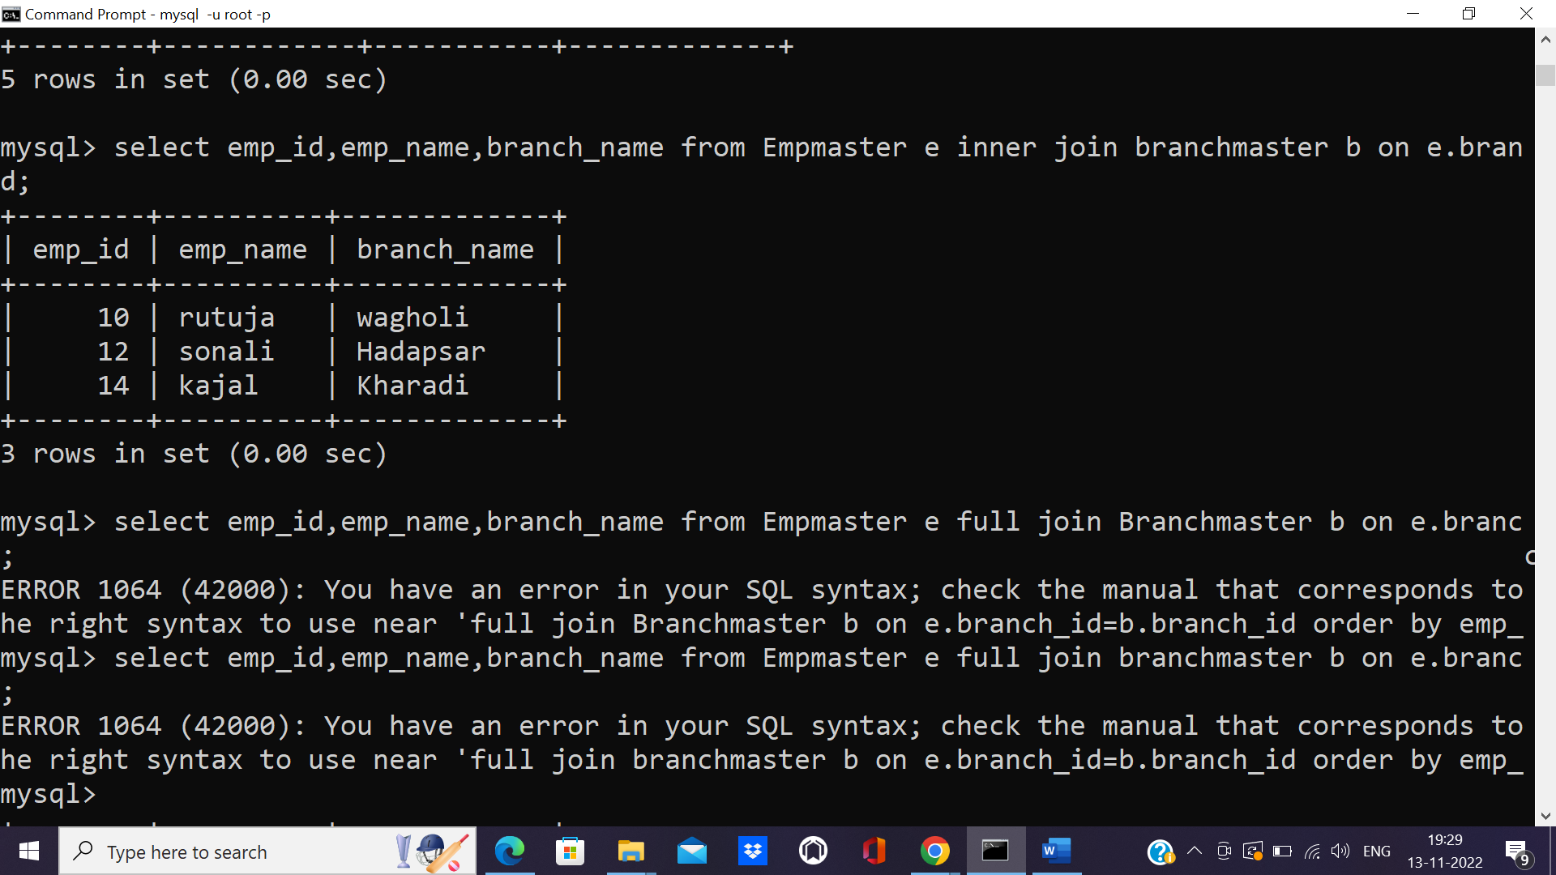

**List the details of employee who belong to admin department along with the branch**

**name to which they belong.**

mysql> select emp_name,dept,branch_name from branchmaster b,Empmaster e where b.branch_id=e.branch_id and dept='manager';

+----------+---------+-------------+

| emp_name | dept | branch_name |

+----------+---------+-------------+

| rutuja | manager | wagholi |

+----------+---------+-------------+

1 row in set (0.10 sec)

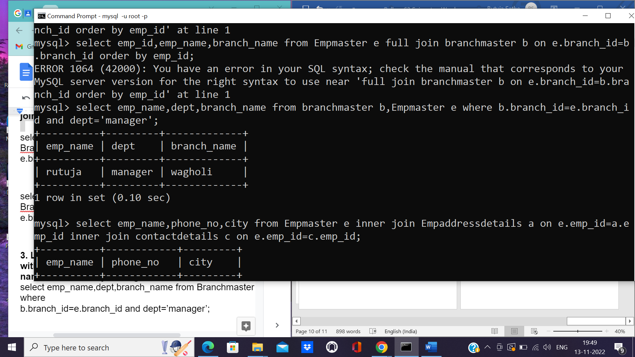

**List the employee name along with the phone no and city using inner join.**

mysql> select emp_name,phone_no,city from Empmaster e inner join Empaddressdetails a on e.emp_id=a.emp_id inner join contactdetails c on e.emp_id=c.emp_id;

+----------+------------+---------+

| emp_name | phone_no | city |

+----------+------------+---------+

| rutuja | 1234567898 | pune |

| nita | 1234667898 | Mumbai |

| nita | 1234667898 | Mumbai |

| sonali | 1224667898 | Kolkata |

| kajal | 1223667998 | cuttack |

+----------+------------+---------+

5 rows in set (0.01 sec)

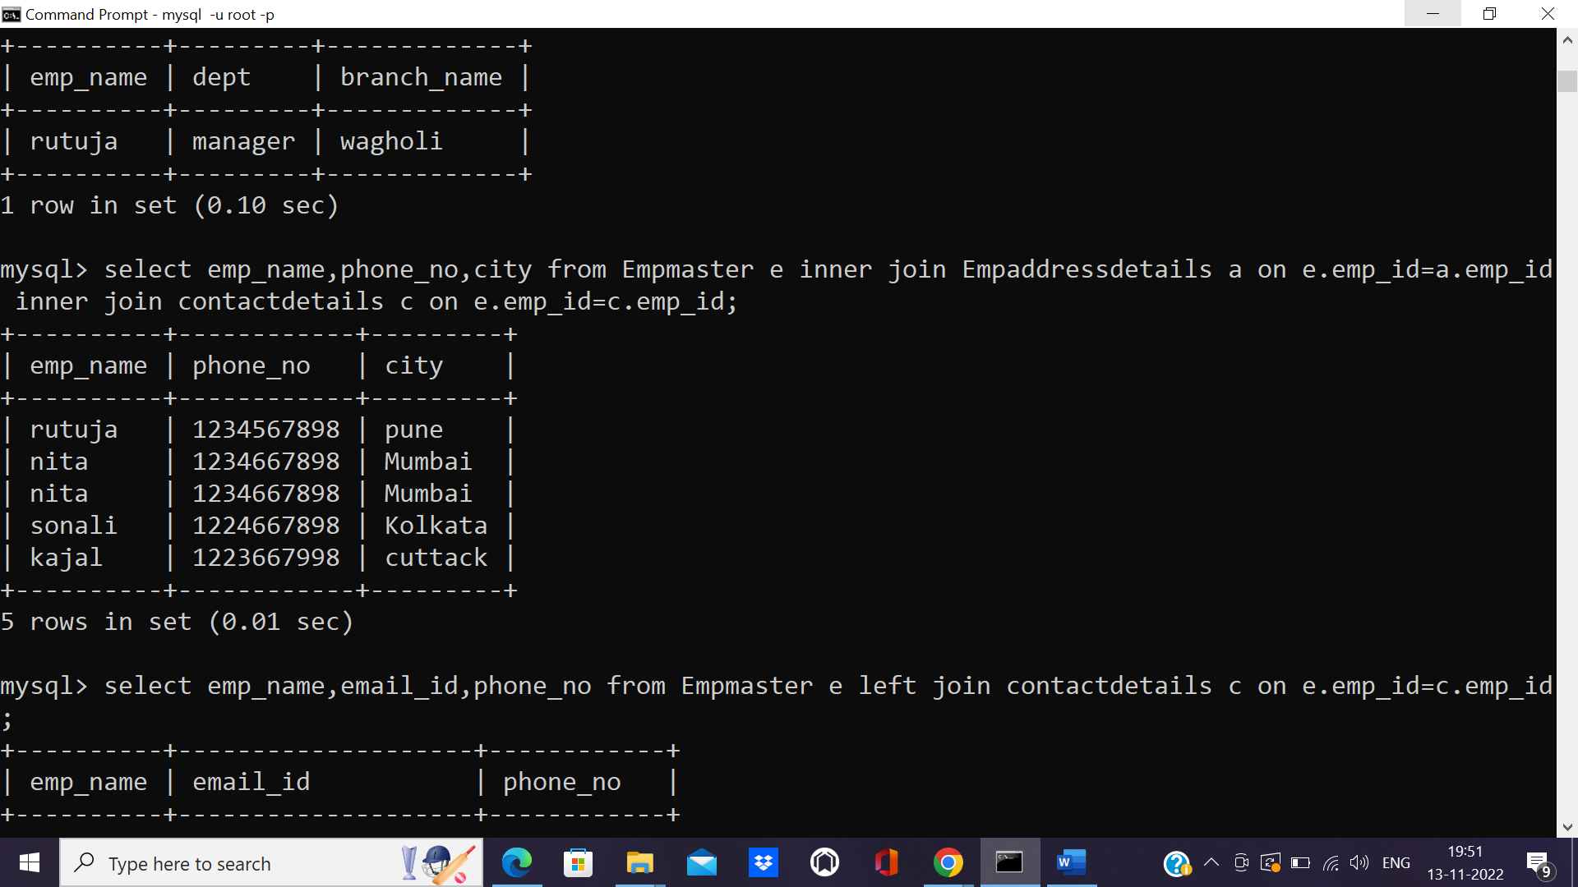

**List the employee name with the contact details**

mysql> select emp_name,email_id,phone_no from Empmaster e left join contactdetails c on e.emp_id=c.emp_id;

+----------+--------------------+------------+

| emp_name | email_id | phone_no |

+----------+--------------------+------------+

| rutuja | rutuja@gmail.com | 1234567898 |

| nita | nita@gmail.com | 1234667898 |

| nita | nita@gmail.com | 1234667898 |

| sonali | sonali@gmail.com | 1224667898 |

| kajal | priyanka@gmail.com | 1223667998 |

| priyanka | NULL | NULL |

+----------+--------------------+------------+

6 rows in set (0.00 sec)

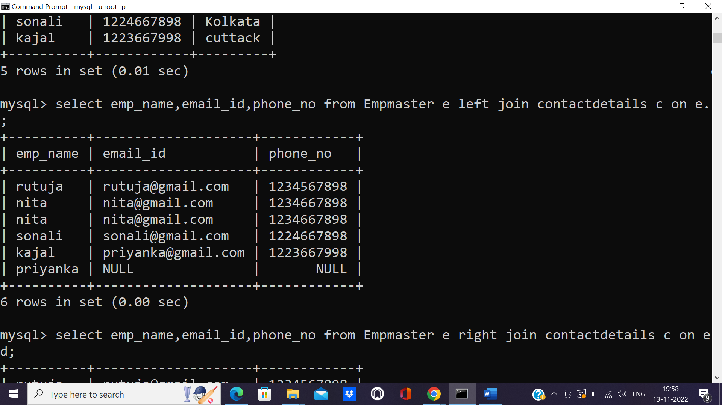

**List the employee contact details irrespective of whether they are working or have left.**

mysql> select emp_name,email_id,phone_no from Empmaster e right join contactdetails c on e.emp_id=c.emp_id;

+----------+--------------------+------------+

| emp_name | email_id | phone_no |

+----------+--------------------+------------+

| rutuja | rutuja@gmail.com | 1234567898 |

| nita | nita@gmail.com | 1234667898 |

| nita | nita@gmail.com | 1234667898 |

| sonali | sonali@gmail.com | 1224667898 |

| NULL | kajal@gmail.com | 1223667898 |

| kajal | priyanka@gmail.com | 1223667998 |

+----------+--------------------+------------+

6 rows in set (0.00 sec)

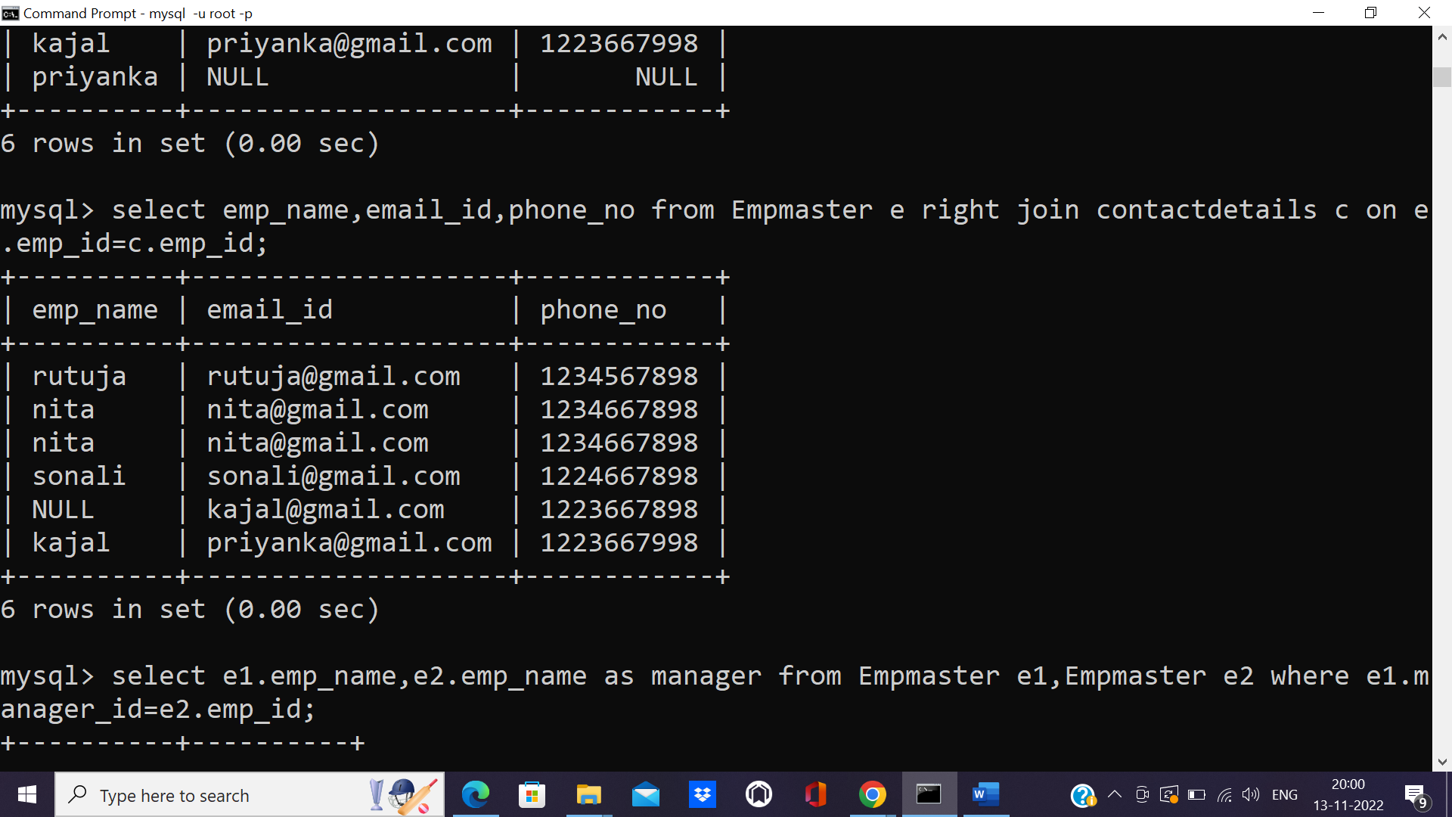

**Retrieve the employee name and their respective manager name.**

mysql> select e1.emp_name,e2.emp_name as manager from Empmaster e1,Empmaster e2 where e1.manager_id=e2.emp_id;

+----------+----------+

| emp_name | manager |

+----------+----------+

| rutuja | nita |

| rutuja | nita |

| nita | sonali |

| nita | sonali |

| kajal | kajal |

| priyanka | priyanka |

+----------+----------+

6 rows in set (0.04 sec)

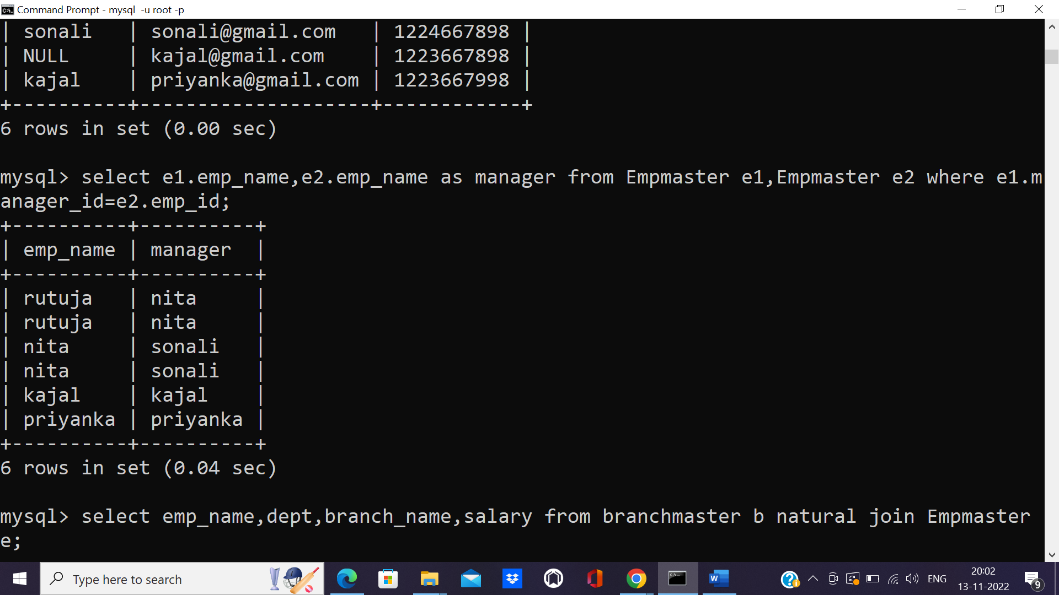

**List the employee details along with branch name using natural join.**

mysql> select emp_name,dept,branch_name,salary from branchmaster b natural join Empmaster e;

+----------+---------+-------------+--------+

| emp_name | dept | branch_name | salary |

+----------+---------+-------------+--------+

| rutuja | manager | wagholi | 40000 |

| sonali | HR | Hadapsar | 50000 |

| kajal | senior | Kharadi | 120000 |

+----------+---------+-------------+--------+

3 rows in set (0.01 sec)

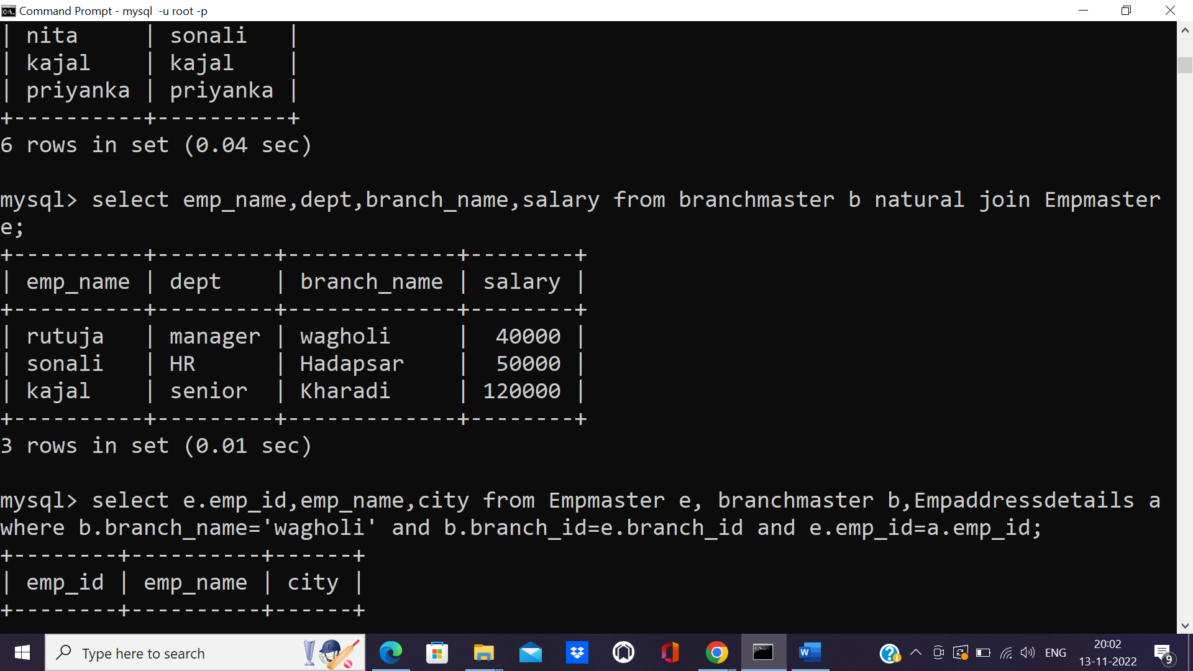

**List the employee names who work at the wagholi branch along with the city of that**

**employee.**

mysql> select e.emp_id,emp_name,city from Empmaster e, branchmaster b,Empaddressdetails a where b.branch_name='wagholi' and b.branch_id=e.branch_id and e.emp_id=a.emp_id;

+--------+----------+------+

| emp_id | emp_name | city |

+--------+----------+------+

| 10 | rutuja | pune |

+--------+----------+------+

1 row in set (0.00 sec)

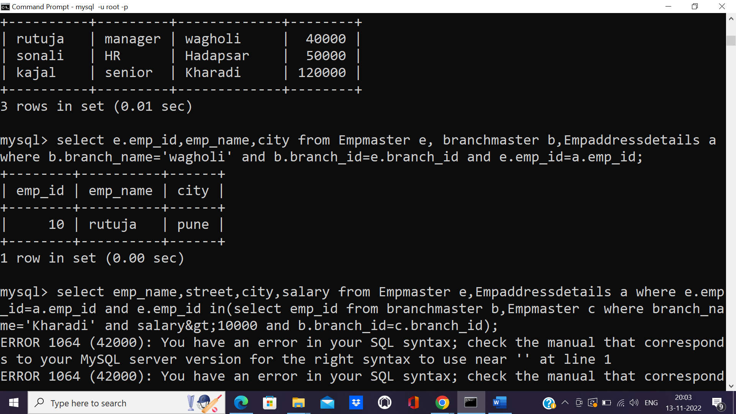

**Find the employee who works at the kharadi branch with salary>120000 and list the**

**employee names with streets and city they live in.**

mysql> select emp_name,street,city,salary from Empmaster e,Empaddressdetails a where e.emp_id=a.emp_id and e.emp_id in(select emp_id from branchmaster b,Empmaster c where branch_name='Kharadi' and salary=120000 and b.branch_id=c.branch_id);

+----------+------------+---------+--------+

| emp_name | street | city | salary |

+----------+------------+---------+--------+

| kajal | Street roa | cuttack | 120000 |

+----------+------------+---------+--------+

1 row in set (0.01 sec)

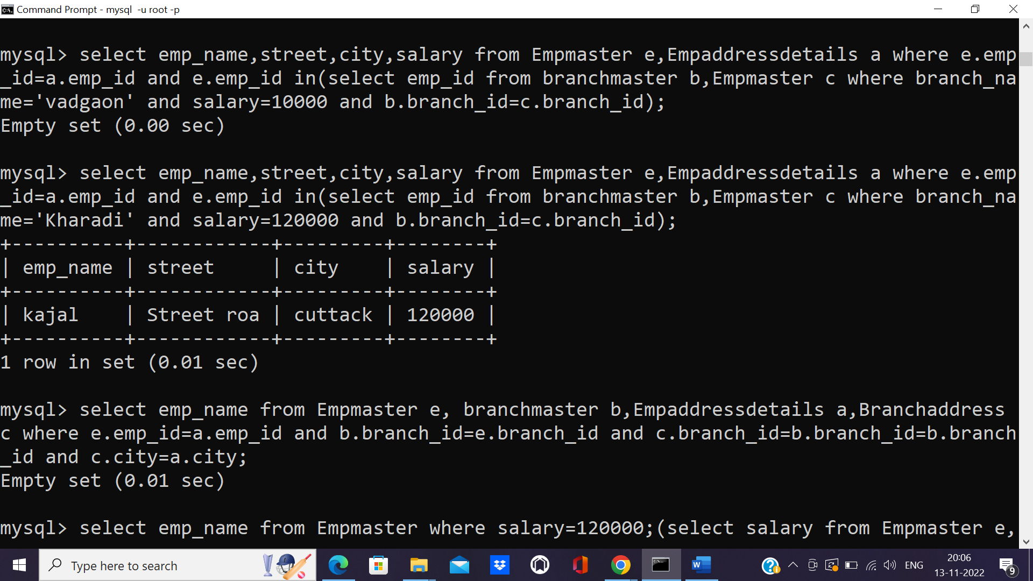

**Find the employees who live and work in same city.**

mysql> select emp_name from Empmaster e, branchmaster b,Empaddressdetails a,Branchaddress c where e.emp_id=a.emp_id and b.branch_id=e.branch_id and c.branch_id=b.branch_id=b.branch_id and c.city=a.city;

Empty set (0.01 sec)

**Find the employees whose salaries are more than everybody who works at branch**

**kharadi.**

mysql> select emp_name from Empmaster where salary=120000;(select salary from Empmaster e,Branchmaster b where e.branch_id.branch_id and branch_name='Kharadi');

+----------+

| emp_name |

+----------+

| kajal |

+----------+

1 row in set (0.00 sec)

